

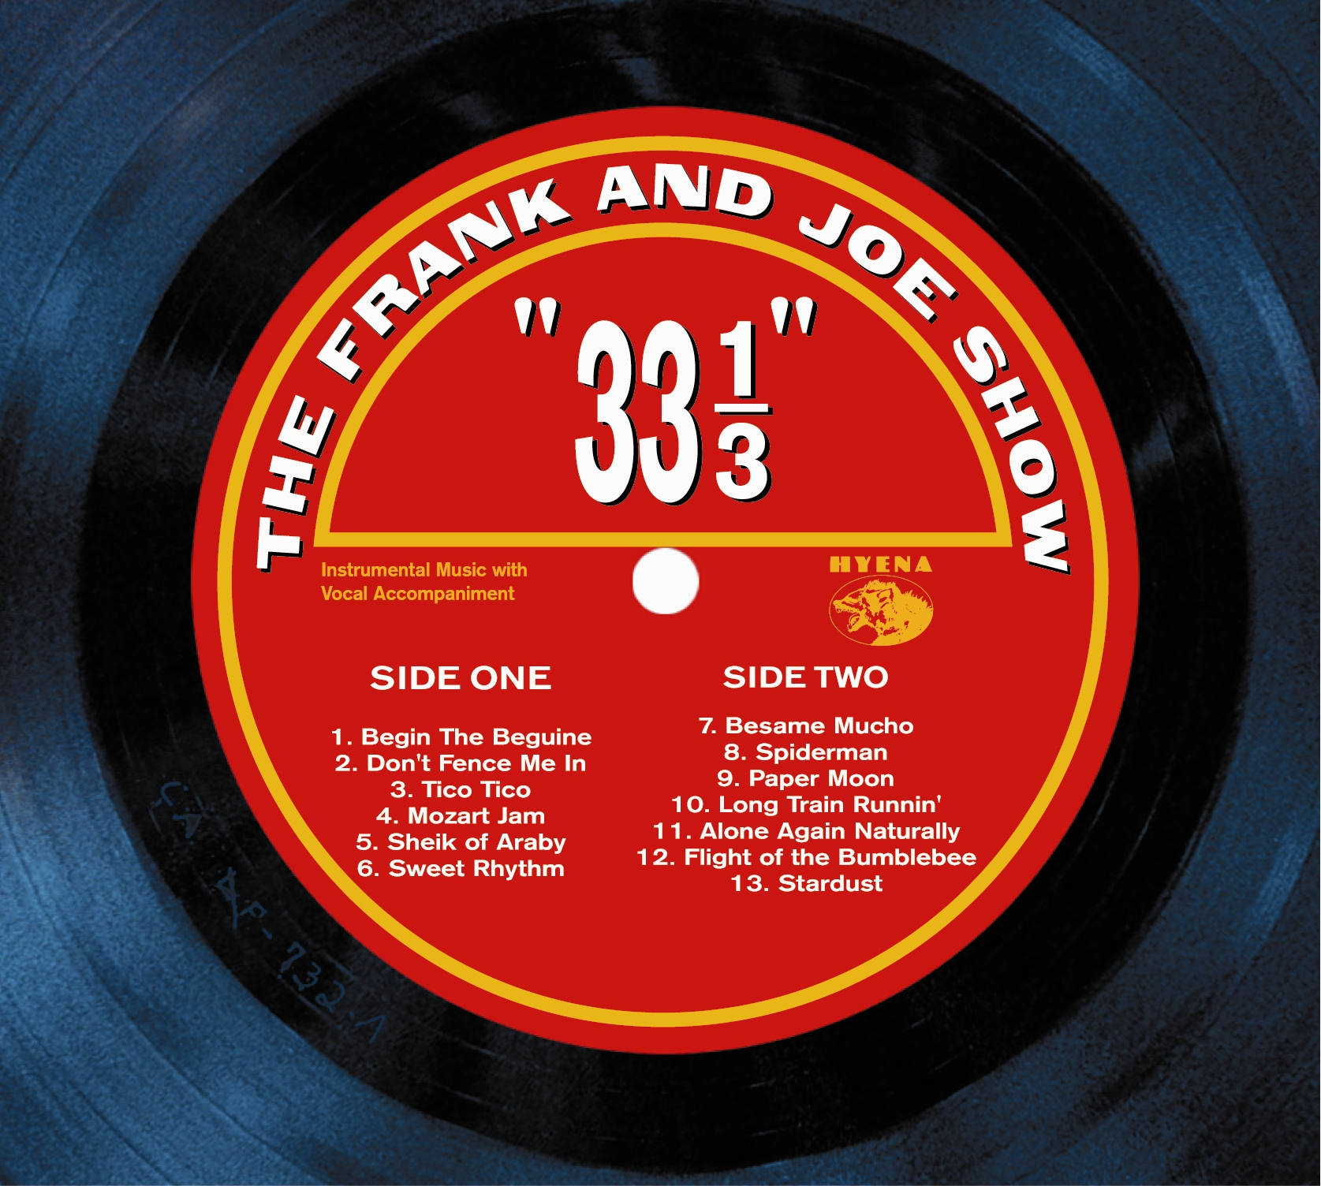

ALL FORMATS AT RADIO
ADULT STANDARD to JAZZ, TRIPLE A to AMERICANA
ARE EMBRACING THE FRANK & JOE SHOW

“I wasn’t familiar with Frank, much less Joe, but I am now and this new album is a winner.” – Don McCulloch/K-Surf (Los Angeles)

“These guys put the ‘F-U’ back in FUN! One of the most enjoyable CDs to date. Frank & Joe are infectious, inventive and awesome!”
– Jim Raposa/Frank & Friends (Nationally Syndicated)

“Remarkable…A truly unique sound…this one will get a lot of play here.”
– Larry Collins/KWXY (Palm Springs, CA)

“Instant response when it hit the air!” – Gary Houser/KABI (Abilene, TX)

“Amazing Guitar Work.”
– Eddie Hubbard/ABC Radio Network (Nationally Syndicated)

“The Frank & Joe Show is what good radio is all about—and I’ll be all over this CD for months to come.” –
Bill Miller/The Bill Miller Show (Nationally Syndicated)

“Fantastic Stuff.” – John Hamel/WNTI (Morristown, NJ)

“This is one of the best I’ve heard in a long time. It reminds me of way back a few decades ago when ‘Take Five’ came out!”
– Alan Rock/WUCF (Orlando, FL)

“I dare anyone to listen & not smile. This is an explosion of happiness.”
– Music of Your Life/Chuck Southcott (Nationally Syndicated)

“I flipped listening to Frank & Joe. It will be added immediately.”
– Jim Manion/WFHB (Bloomington, IN)

It's a blend of Bob Wills and The Texas Playboys, Roy Rogers and Dale Evans, The Andrews Sister and Charlie Christian. It's a wide open ball game. There is a world wide appeal to this!” – Dick Crockett/The Voice (Sacramento, CA)

