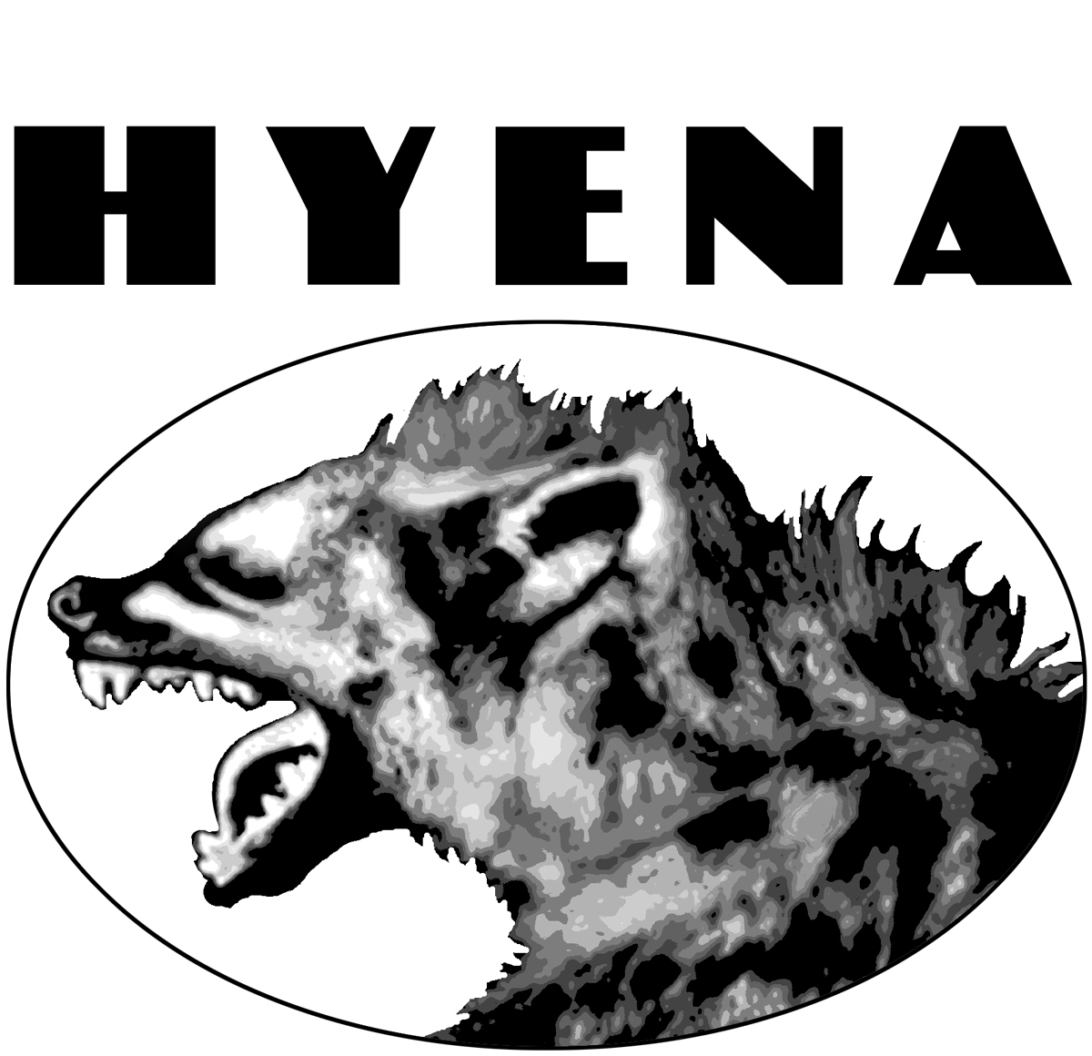

MAY 2004

The Frank and Joe Show: The Hoot Factor at Sweet Rhythm
By Dr. Judith Schlesinger
These guys are a hoot. On first hearing Frank & Joe's debut CD on Hyena Records, 33 1/3, I e-mailed Joe that very thought, and he wrote back, “what is this 'hoot'?” I said it refers to something that's fun and delightful, like their CD. Turns out it's also a hoot to watch “The Frank and Joe Show” itself, as I did recently at Sweet Rhythm, where it's been running for months every Sunday night. The band that evening consisted of Joe Ascione [ASH-ee-oh-nee] on djembe (a small West African drum, held between the knees), bongos, high hat, and sundry other percussion; Frank Vignola on lead guitar, Kent Smith on rhythm, Gary Mazzaroppi on bass and guitar, and Rich Zucker and Chuck Feruggia on additional assorted noisemakers (djembes, bell tree, tambourine, triangle, train whistle, and hands).
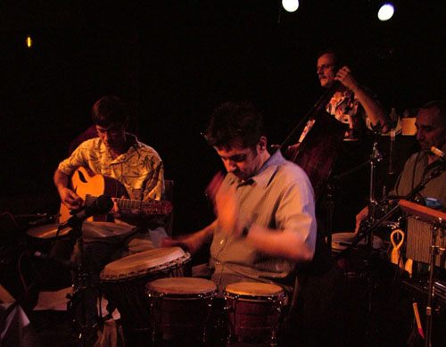
The hoot factor was intensified by the playful kibitzing of the band between tunes, which included a contest for the loudest shirt of the night (Gary won) and an update on Frank's latest bowling scores, followed by a short communal chorus of a dumb little ditty called “The Bowling Song.” At one point, Joe threw out the question, “How do you know when you run out of invisible ink?” (BUCKetofish!)
In describing The Frank and Joe Show, whether live or Memorex, it would be simpler just to say it's a hoot, and leave it at that, since these guys slide across the usual boundaries of category and style. (The bin-tenders at Tower will go crazy figuring out where to file it.) While there are traditional anchors here and there -- most obviously to Django and the gypsy guitar groove -- their repertoire and approach are sui generis. It's a group full of paradoxes: retro yet contemporary, innovative but familiar, and tongue-in-cheek while musically quite serious. “But,” say the purists, “is it jazz“?
To answer those tiresome folks, yes, Virginia, it has improvisation and solos, and fine bluesy moments, but, as producer Joel Dorn says, “it's not your typical jazz guitar album. It's 'new/old,' and the newest version of classic music that I've heard in years.” “Classic” is represented literally, with a brief and blistering “Flight of the Bumblebee” and the exciting “Mozart Jam,” when Joe's hands become a complete blur. That happens often (see the locomotive “Spiderman,” for example). There are jazz classics as well, such as “Stardust” and “Paper Moon”; a sprightly Latin legend, “Tico Tico,”; and a transformation of the Doobie Brothers tune, “Long Train Running” (live, they did another DB hit, “Without Love”). One of my favorites is the “Sweet Rhythm” jam, where Bo Diddley wanders around in the casbah; the combination of Middle East and classic rock is brilliant and delightful.
“It's a group full of paradoxes: retro yet contemporary, innovative but familiar, and tongue-in-cheek while musically quite serious.”
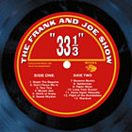
33 1/3 took eight months to put together, and was recorded in Dorn's office: “we ran wires into the Pro Tools room, and fed the mics into the lounge. People are impressed with the sound, but it was just recorded in some guy's office.” Dorn is also pleased with the final product: “Rarely am I this happy with a record I've produced,” he told me. This is quite a statement, since, as he notes in the liners, he started making records when you could buy a fully-loaded Eldorado for less than five grand. The CD's title is an homage to the scope and coherence of the LP: “even though it lives on a CD, '33 1/3' is an album,” he says.
All the percussion on the CD is Joe, and all the guitars are Frank; both are absolute virtuosos who met in 1989 and have been buds and colleagues ever since. To date, Joe has been on 60 albums, leading on two; he plans to keep drumming as long as he can, given his recent MS diagnosis. “Who would've thought that I'd become the face of MS?” he said with his usual wry humor (his birthday performance on March 14 was a fundraiser; he's involved in the MS walks, and was recently interviewed by NBC TV).
Despite being born and raised in Long Island, New York, Frank was the Grand National Banjo Champion of Canada at age 12. Like Joe, he's a yeoman sideman, and has released lead CDs on Concord and Nagel-Heyer. Frank also founded Hot Club USA in 1997, which tours in tribute to Django Reinhardt and Stephane Grapelli.
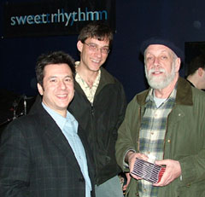
The two maestros are perfectly matched. “Because the guitar is out front, people don't fully appreciate Joe's contribution,” Dorn (see right) says. “Without Joe setting up the rhythm, it would be impossible for the music to fly like that. It's a true partnership.” Their mutual affection and respect is unmistakable in a live setting, where the band and the audience make a jolly bond as well.
The CD adds three guest vocals, including Dr. John's patented drollity on “The Sheik of Araby,” where he also plays piano under his real name, Mac Rebennack. Janis Siegel multi-tracks the campy “Don't Fence Me In,” which is part prairie and part Hot Club de Paris. I was trying to praise Jane Monheit's creamy vocal on “Besame Mucho” to a friend; he said he could go to his grave quite happily without ever hearing that song again. I understood, since I feel the same way about “Summertime,” but this “Besame” is archeological, scraping off decades of triteness to reveal the tune's original romantic yearning. The band plays it straight up and sweet, but with no paper parasols.
Well worth a trip from the hinterlands, the show continues at Sweet Rhythm (88 Seventh Avenue South) every Sunday night. May 9 is the CD release party, where even Miss Cleo could predict an exponential increase in the hoot factor (I wonder how many people will bring their mothers?). On May 15, at 4 pm, WBGO will feature a live broadcast of The Frank & Joe Show.
Visit Frank and Joe on the web at www.thefrankandjoeshow.com.
Photo Credit
Judith Schlesinger

