Jenna Mammina

QUOTES

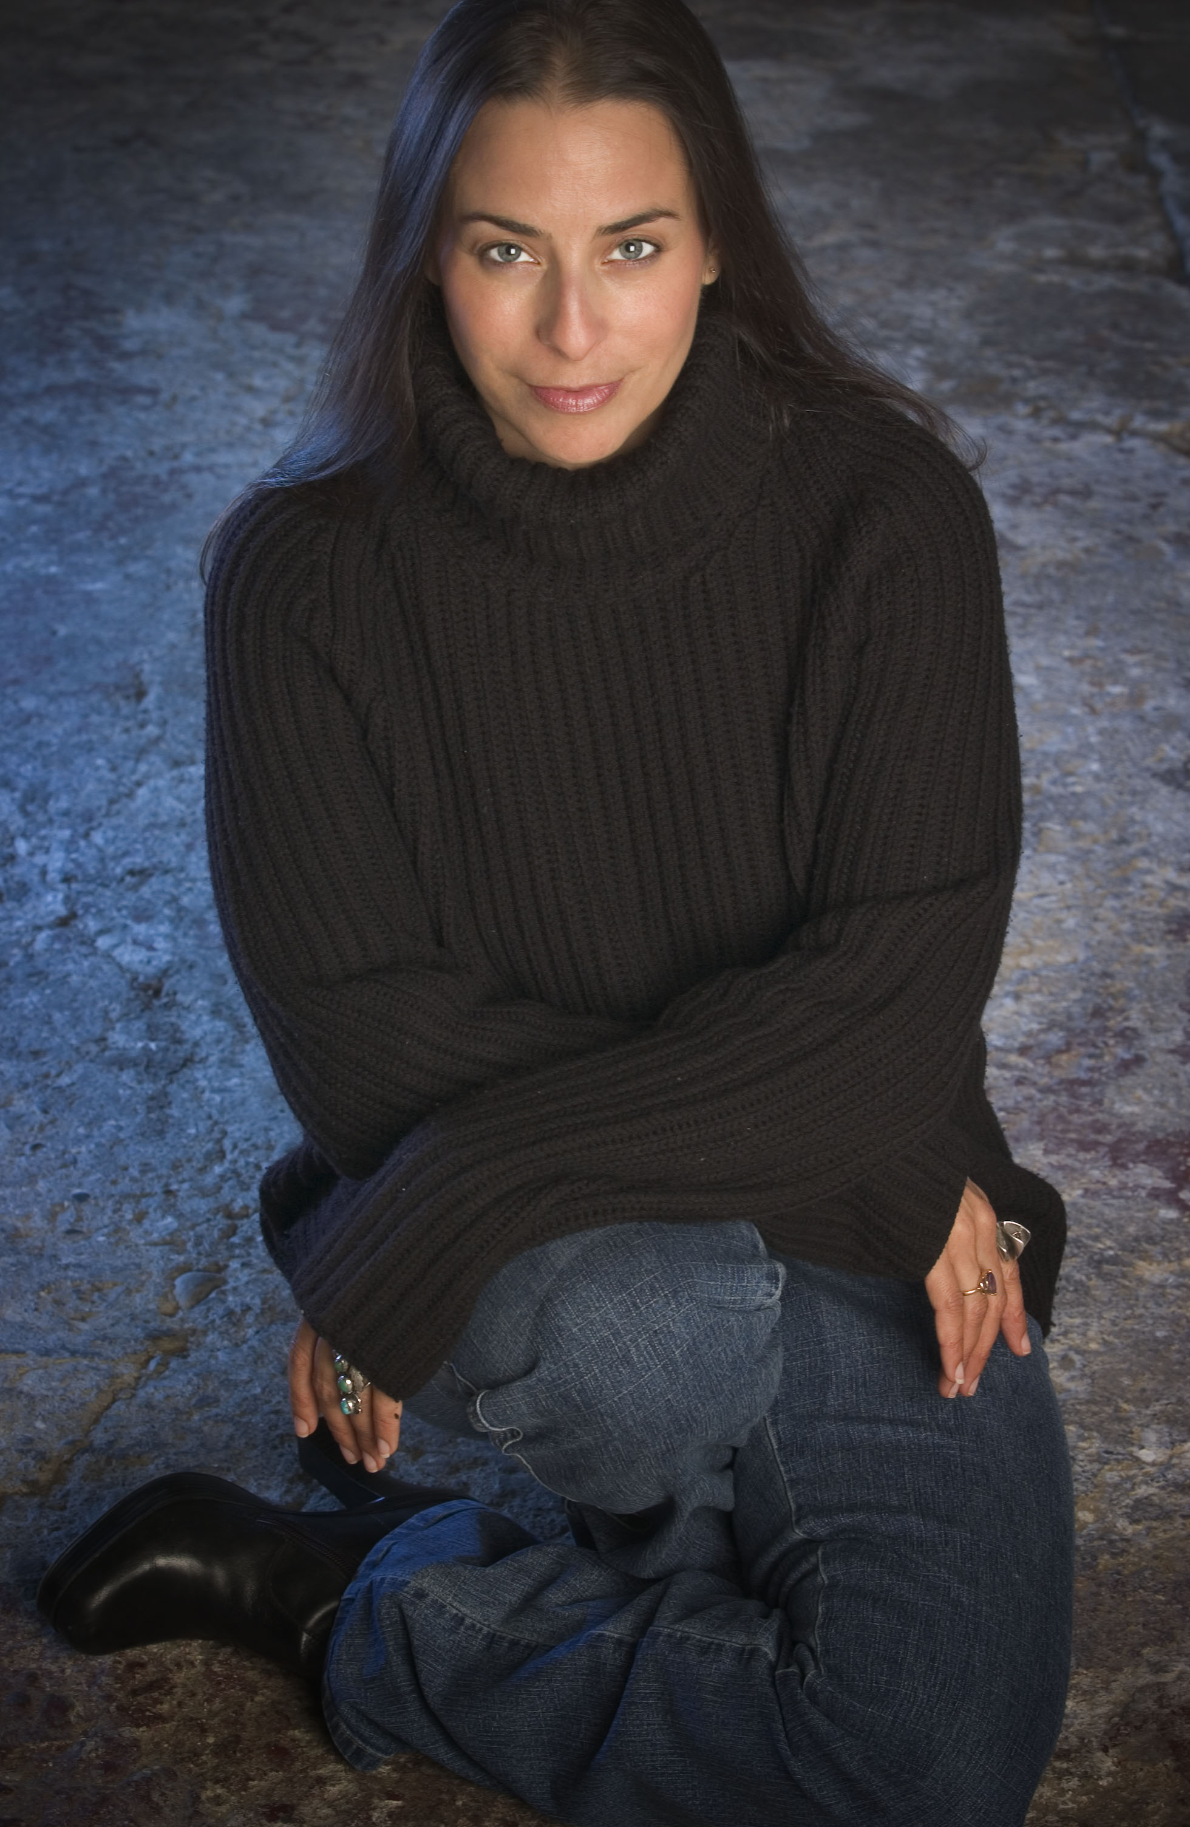
"A free soul, a breath of fresh air onstage."
- Phil Elwood, San Francisco Chronicle
"A remarkable CD!"
- Derk Richardson, San Francisco Bay Guardian
"Jenna Mammina's voice radiates warmth and subtlety. She caresses each note with just the right charm. She hits that jazz spot in your heart and soul."
- Paula Edelstein, SoundsofTimelessJazz.com
"I have fallen under Jenna's powerful spell. I hope to never recover from it."
- Jim Harrington, Oakland Tribune
"Jenna jazzes my world."
- Penn Jillette
"Ms. Mammina, you have a new fan."
- Fred W. Harris, Skyjazz Internet Radio
"Mammina deserves to be more widely heard."
- Don Heckman - LA Times
"Jenna won the hearts of her Monterey audience and gained many new fans. It was a fun and adventurous performance."
- Tim Jackson, Monterey Jazz Festival
"In Mammina's singing, San Francisco chic meets midwestern moxy. Joni Mitchell meets Abbey Lincoln and an audience dissolves into delight."
- Neil Tesser, host of "Miles Ahead" Jazz from Chicago at 1240 and 1470 AM
"In a class by herself!"
- Jen Earls, Chicago Free Press
"It's not that Jenna Mammina's got that uniquely uncategorizable voice, but equally important that she uses its inviting warmth on the most impeccable collection of songs from a wide array of styles - rock and jazz especially - with the classiest arrangements around."
- Larry Kelp - Music Writer KPFA-FM
"I have fallen under Jenna's powerful spell. I hope to never recover from it."
- Jim Harrington - Oakland Tribune
"She takes the lyric of each tune and wraps them around herself like a warm comfortable cloak."
- Wayne Saroyan, JazzWest.com
"While covering the Monterey Jazz festival, I caught the 1st two songs of Jenna's set there and was totally captivated and charmed by her humor, unique style and creativity...For me it was one of the highlights of the festival...One of the joys in this festival is "discovering" hidden, off-the-beaten path gems and Jenna definitely is a bright, shining 2-carat diamond."
- Mac McDonald, Monterey Herald
"It's clear Mammina only covers material she holds dear, and these interpretations feel like offerings, musical gems she hands wholeheartedly over to her listener."
- Sylvia Chan, Urban View
"There's a cleverness and jocularity about Jenna's way of singing a song that coupled with her unique voice and malleable sensibility, suggests "discovery" in a big way - is just around the corner."
- Willard Jenkins, Africana.com
"For two consecutive years I've witnessed Jenna's overwhelmingly positive effect on the Mount Hood Jazz Festival's audiences. Her repertoire and delivery of the material captivates her listeners. Under the Influence and Meant to Be are played regularly on the airwaves of KMHD, usually by request. I've seen diehard jazz purists and novices to the music succumb to the charms of Jenna's musical talents. This is a vocalist that truly deserves wider recognition."
- Mary Burlingame, KMHD-FM, Producer of Home Grown Jazz
"Along with good musical instincts, her biggest asset may be an appealing personality that connects with listeners right away. Together they're allowing Mammina to emerge from the sea of unknowns with a splash."
- Marty Hughley, The Oregonian
"One of my top 10."
- Lee Hildebrand, East Bay Express
"Meant To Be is already lighting up the phones at WDET! Listeners are knocked out by Jenna's ability to not only cover tunes by the likes of Steely Dan but also to make them swing. Jenna's voice is the aural equivalent of a very dry martini - elegant and intoxicating."
- Martin Bandyke, Music Director, WDET-FM 101.9 Detroit

Agency
Jim Wadsworth Productions
Steve Frumkin 216.721.4982 wadsworthjazz@aol.com

Jim Wadsworth 216.721.5624 jwadsworth@aol.com

